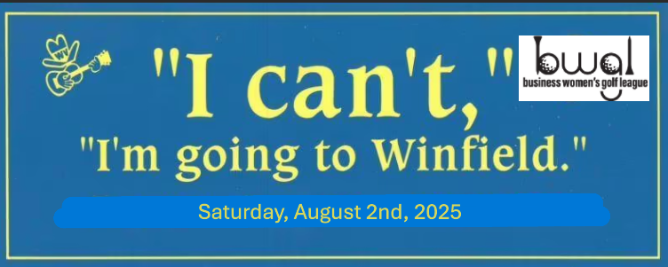
Quail Ridge Blue Grass Festival Golf Tournament
3905 Quail Ridge Dr., Winfield, Kansas 67156
Saturday, August 2, 2025
OK Ladies! Lets get out our Tie Dye clothes and get ready for The Bluegrass Festival.
- First tee time starting at 9:00 a.m.
- There are no Silver Tees on this Course
- Entry: $42.50 (includes green fee, cart and range balls)
- Prize Fund: $7.00
- Total: $49.50
Lunch is not provided, but there is a Mexican Restaurant next door if anyone is interested after play
$49.50 entry due by July 25, 2025 payable to BWGL and please send to:
Ann Wagner, 9642 E. Clubhouse Ct., Wichita, Kansas 67226

